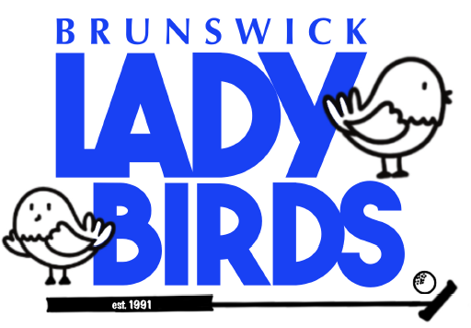
2025 TOURNAMENT DATES

Note to any new reps: greens fees should include $4 for balls & $1 bag drop tip

9:00 April 9th Wednesday Oak Island $57

9:00 April 21st Monday Compass Point $60

9:00 May 5th Monday Bricklanding $47

9:00 May 12th Monday Lockwood Folly $59

8:30 May 15th Thursday Carolina National $56

9:00 June 3rd Tuesday Sea Trail $55

9:00 June 25th Wednesday Meadowlands $54

9:00 July 7th Monday St James $52

9:00 August 18th Monday Magnolia Green $55

8:30 September 22nd Monday Rivers Edge $61
“The Cup”
Rain Date:
9:00 November 5th Wednesday Rivers Edge
“The Cup”

Awards Luncheon: TBD

*Updated 02/13/2025

